Name : Praneeth Reddy

Trainer : Satinnder

DAY 1 : Difference Between Single core, Dual Core, Quad Core, i3 and i5 processors

Single Core:
- Contains one processing unit or core.
- Can handle one task at a time. Performance is limited to single-threaded applications.
- Typically consumes less power than multi-core processors.
- Basic tasks like word processing, web browsing, and simple applications.

Dual Core:
1 Contains two processing units or cores on a single chip.
2 Can handle two tasks simultaneously. Better multitasking performance compared to single core.
3 Consumes more power than single core but less than processors with more cores.
4 General computing, light gaming, and everyday multitasking.

Quad Core:
- Contains four processing units or cores.
- Can handle four tasks simultaneously. Significantly better performance for multitasking and multi-threaded applications.
- Higher than dual core processors.
- More intensive tasks like gaming, video editing, and running multiple applications simultaneously.
Intel Core i5 :
- Usually quad core, though some may have more cores (e.g., 6 cores in newer generations).
- Mid-range performance suitable for a wide range of tasks. Offers good multitasking and multi-threaded performance.
- Balanced power consumption, with some models focusing on energy efficiency (U-series) and others on performance (H-series, K-series).
- Includes features like Turbo Boost (dynamic frequency scaling), Hyper-Threading (in some models), and integrated graphics.
- General productivity, moderate gaming, and mainstream computing tasks.

Intel Core i7 :
- Typically more cores than i5 (quad core, hexacore, or even octa-core in newer generations). Also higher clock speeds.
- High performance for demanding applications. Often includes Hyper-Threading, allowing each core to handle two threads simultaneously.
- Higher power consumption compared to i5, especially in performance-focused models.
- Enhanced features like higher cache size, better integrated graphics, advanced Turbo Boost, and Hyper-Threading.
- High-end gaming, professional content creation (video editing, 3D rendering), and other intensive tasks.

Comparison :

Single Core vs. Dual Core vs. Quad Core: The main difference is the number of cores, which directly impacts multitasking and performance in multi-threaded applications. More cores generally mean better performance for multitasking and handling complex applications.
i5 vs. i7 Processors:
  - Performance: i7 processors generally offer better performance due to higher core counts, higher clock speeds, and advanced features.
  - Features: i7 processors typically have Hyper-Threading, larger cache sizes, and better Turbo Boost technology compared to i5.
  - Use Cases: i5 is suitable for most users with general productivity and moderate gaming needs, while i7 is aimed at power users who need high performance for demanding applications.

Parameters to be Considered :
- Generations: Intel processors are released in generations, with each new generation generally bringing improvements in performance, power efficiency, and features.
- Power Consumption and Heat: More powerful processors like i7 tend to consume more power and generate more heat, which requires better cooling solutions.
- Price: i7 processors are typically more expensive than i5 processors due to their higher performance and advanced features.

Considering the generations in processor, power consumption, heat, price and other factors from the above I recommend Intel core i5 processor for students and a fresher who just started their career.

DAY 2 :

DAY 3 :

LAB 1
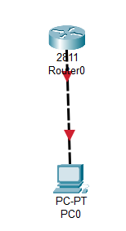

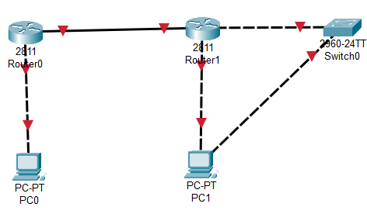

Task 2:
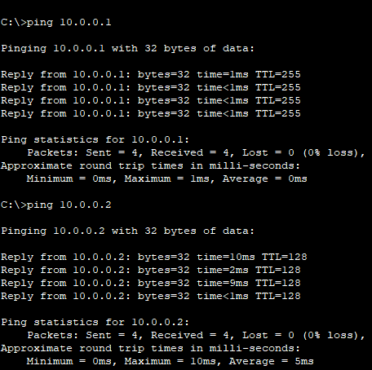
Task 3:
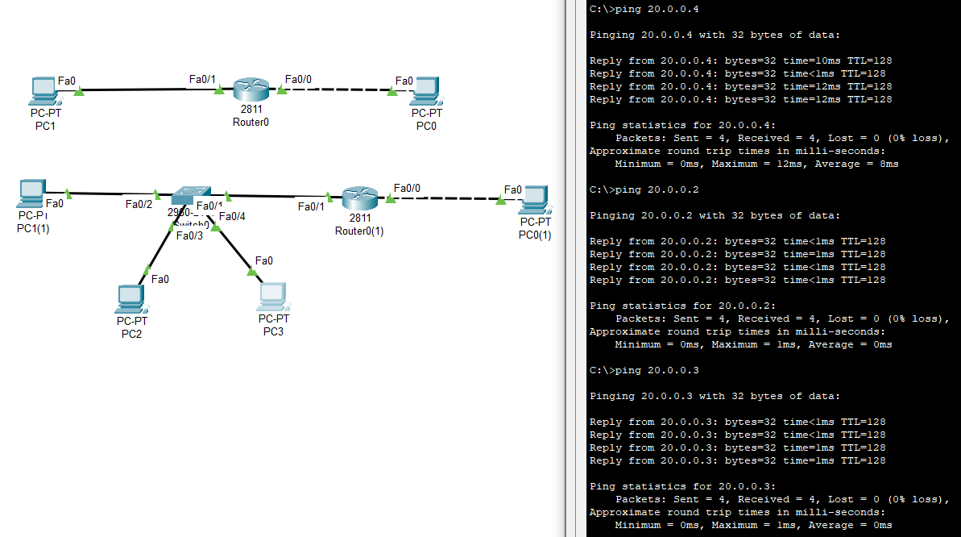

Task 4:
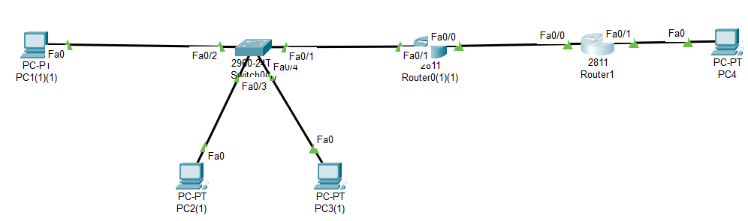
Connection | R1 F0/0 | R1 F0/1 | R2 F0/0 | R2 F0/1
PC1 | Connected (default) | Connected | No | No
PC2 | Connected (default) | Connected | No | No
PC3 | Connected (default) | Connected | No | No
PC4 | NO | No | Connected(default) | Connected

DAY 4:
Task 1:
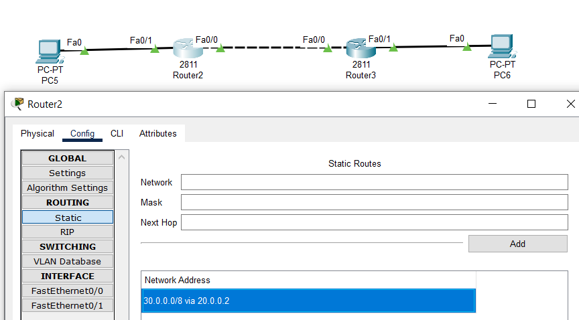

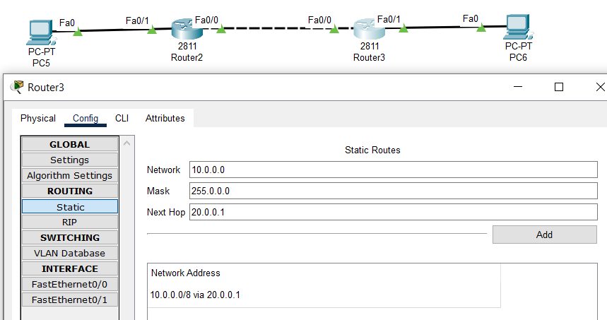

DAY 5
TASK 1:
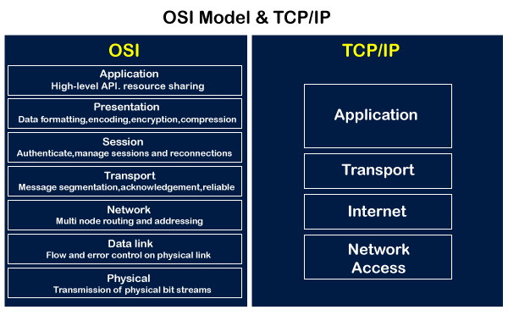

Parameters | OSI Model | TCP/IP Model
Full Form | OSI stands for Open Systems Interconnection. | TCP/IP stands for Transmission Control Protocol/Internet Protocol.
Layers | It has 7 layers. | It has 4 layers.
Usage | It is low in usage. | It is mostly used.
Approach | It is vertically approached. | It is horizontally approached.
Delivery | Delivery of the package is guaranteed in OSI Model. | Delivery of the package is not guaranteed in TCP/IP Model.
Replacement | Replacement of tools and changes can easily be done in this model. | Replacing the tools is not easy as it is in OSI Model.
Reliability | It is less reliable than TCP/IP Model. | It is more reliable than OSI Model.

Layer 7 protocols and their port numbers

• HTTP (HyperText Transfer Protocol)
- Port 80: Used for web traffic and serving web pages.
• HTTPS (HyperText Transfer Protocol Secure)
- Port 443: Used for secure web traffic using SSL/TLS encryption.
• FTP (File Transfer Protocol)
- Port 21: Used for transferring files between a client and a server.
- Port 20: Used for the data transfer channel in active mode.
• SMTP (Simple Mail Transfer Protocol)
- Port 25: Used for sending email.
- Port 587: Used for sending email securely with STARTTLS.
- Port 465: Used for secure SMTP over SSL.
DNS (Domain Name System)
- Port 53: Used for domain name resolution (both TCP and UDP).

SNMP (Simple Network Management Protocol)
- Port 161: Used for network management and monitoring.
- Port 162: Used for SNMP trap messages.
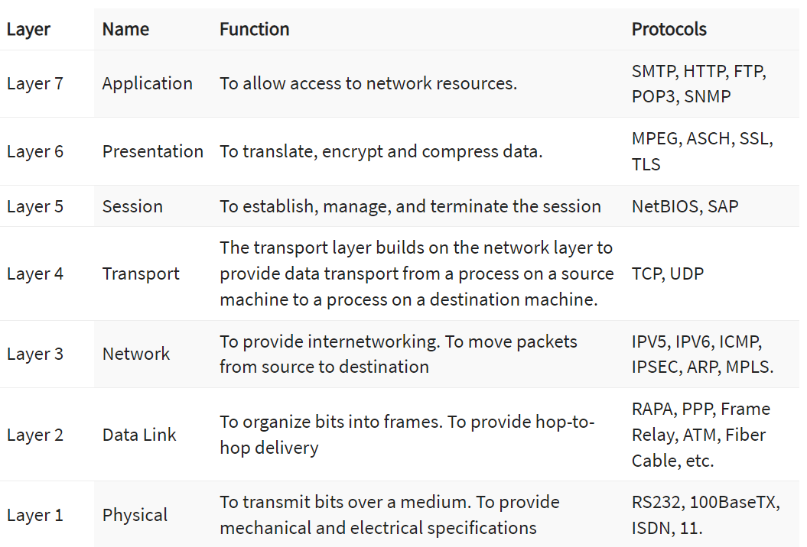

Task 2:
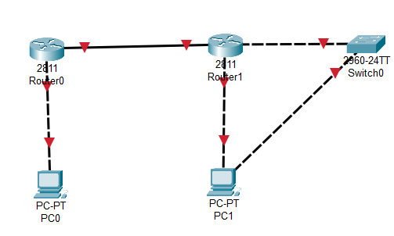
Router>
Router>enable
Router#
Router#configure terminal
Enter configuration commands, one per line. End with CNTL/Z.
Router(config)#interface
% Incomplete command.
Router(config)#interface fastEthernet
% Incomplete command.
Router(config)#interface fastEthernet 0/0
Router(config-if)#exit
Router(config)#interface fastEthernet 0/1
Router(config-if)#ip nat outside
Router(config-if)#exit
Router(config)#interface fastEthernet 0/0
Router(config-if)#ip nat inside
Router(config-if)#exit
Router(config)#access-list 1 ?
deny Specify packets to reject
permit Specify packets to forward
remark Access list entry comment
Router(config)#access-list 1 permit ?
A.B.C.D Address to match
any Any source host
host A single host address
Router(config)#access-list 1 permit any ?
<cr>
Router(config)#access-list 1 permit any
Router(config)#ip nat ?
inside Inside address translation
outside Outside address translation
pool Define pool of addresses
Router(config)#ip nat inside ?
source Source address translation
Router(config)#ip nat inside source ?
list Specify access list describing local addresses
static Specify static local->global mapping
Router(config)#ip nat inside source list ?
<1-199> Access list number for local addresses
WORD Access list name for local addresses
Router(config)#ip nat inside source list 1 ?
interface Specify interface for global address
pool Name pool of global addresses
Router(config)#ip nat inside source list 1 interface ?
Ethernet IEEE 802.3
FastEthernet FastEthernet IEEE 802.3
GigabitEthernet GigabitEthernet IEEE 802.3z
Serial Serial
Router(config)#ip nat inside source list 1 interface FastEthernet ?
<0-9> FastEthernet interface number
Router(config)#ip nat inside source list 1 interface FastEthernet 0/1 ?
overload Overload an address translation
<cr>
Router(config)#ip nat inside source list 1 interface FastEthernet 0/1
Router(config)#interface fastethernet
% Incomplete command.
Router(config)#interface fastethernet 0/1
Router(config-if)#ip nat outside
Router(config-if)#interface fastethernet 0/0
Router(config-if)#no interface fastethernet 0/0
% Removal of physical interfaces is not permitted
Router(config)#interface fastethernet 0/1
Router(config-if)#ip nat outisde
^
% Invalid input detected at '^' marker.
Router(config-if)#ip nat outside
Router(config-if)#exit
Router(config)#interface fastethernet 0/0
Router(config-if)#ip nat inside
Router(config-if)#exit
Router(config)#Enter configuration commands, one per line. End with CNTL/Z.
Router(config)#show all show ip nat translat^Z
Router#
%SYS-5-CONFIG_I: Configured from console by console
^Z
Router#
Router#
Router#configure terminal
Enter configuration commands, one per line. End with CNTL/Z.
Router(config)#interface
% Incomplete command.
Router(config)#interface fastethernet 0/1
Router(config-if)#ip nat outside
Router(config-if)#exit
Router(config)#interface fastethernet 0/0
Router(config-if)#ip nat inside
Router(config-if)#exit
Router(config)#

PING
